Version: 0.1 English

September 2020

Author: Marc van den Elshout

Uniview Doorbell

Instalation Manual

# Intro

Installation manual of the Uniview Doorbell. This document explaines how the device can be installed and configured. Besides that there is information about smartphone settings regarding the app.

The Uniview Doorbell is a small intercomdoorbell that can be managed with the EZLive application.

EZCloud connection is needed for operation.

The device has a 1080P resolution and IP65 degree of protection, because of that the device is able to get a clear image outside. Also IR Night Vision and Motion Detetction are onboard. Playback is possible when SD card is installed.

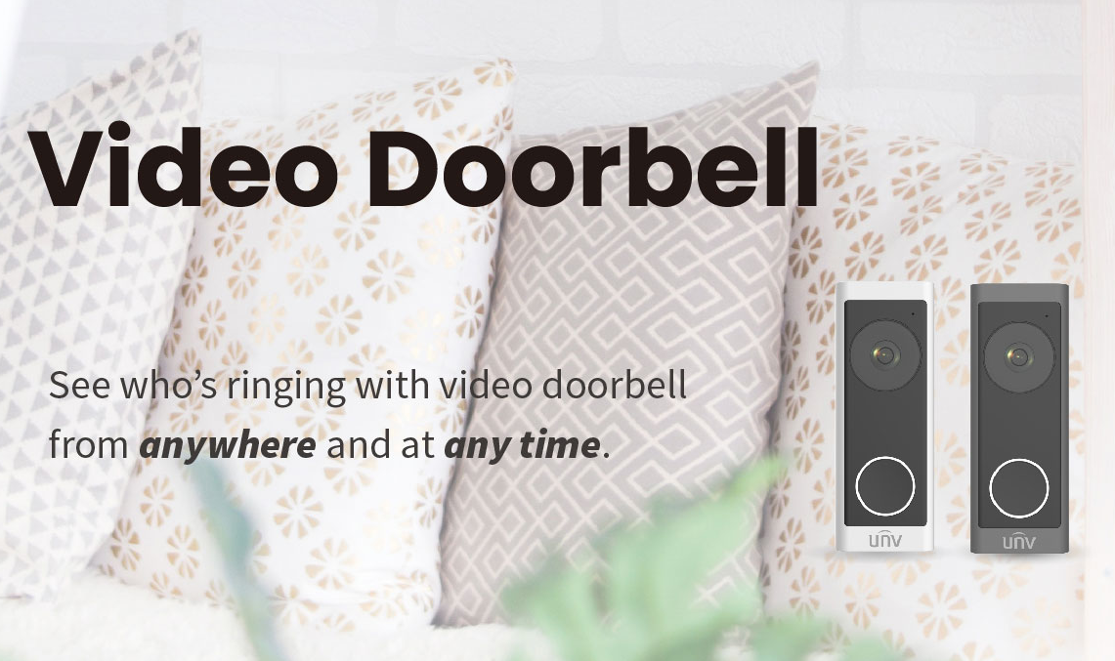

Content

Intro 1

1. Appearance 3

2. In the box 5

3. Installation 7

4. EZLive mobile app 14

5. Setup 15

6. Factory Default 22

7. Share with other user 23

8. Settings iPhone 25

9. Settings Android 26

10. Important 27

# Appearance

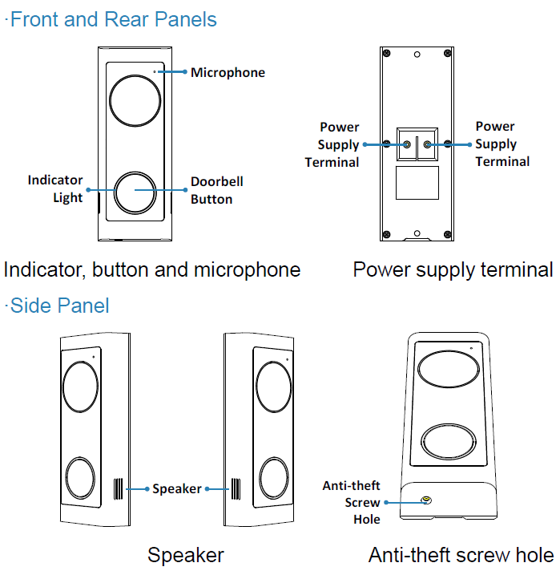

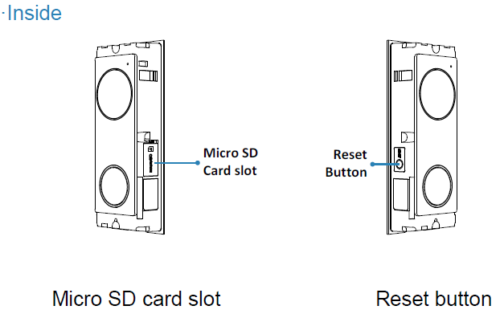

# In the box

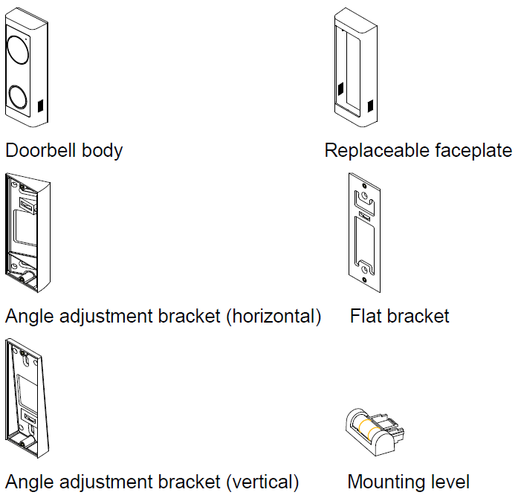

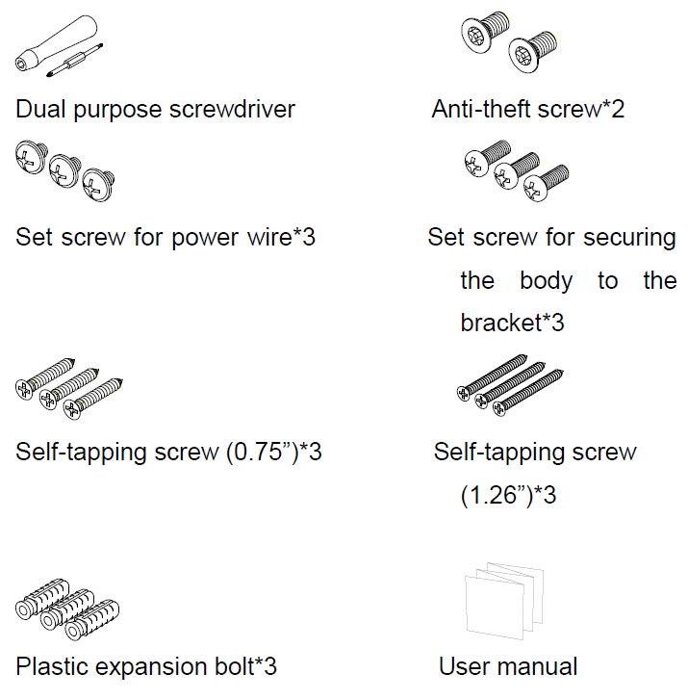

# Installation

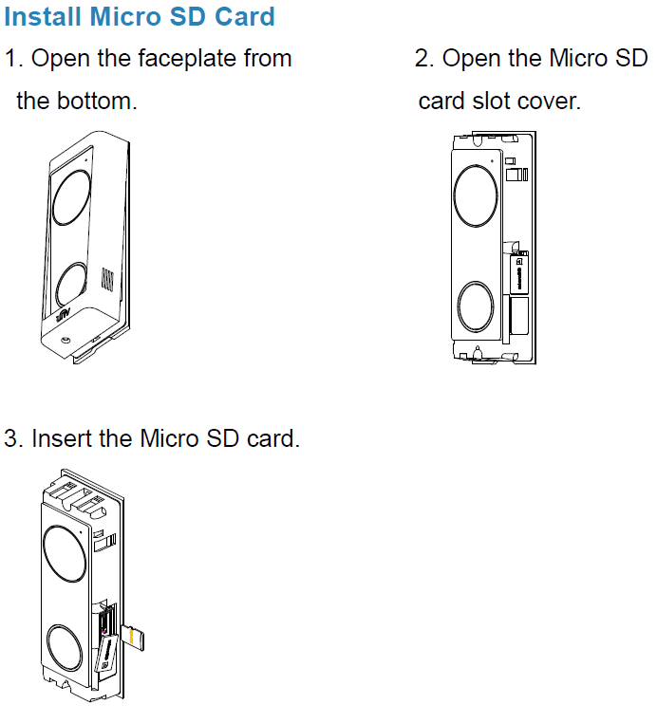

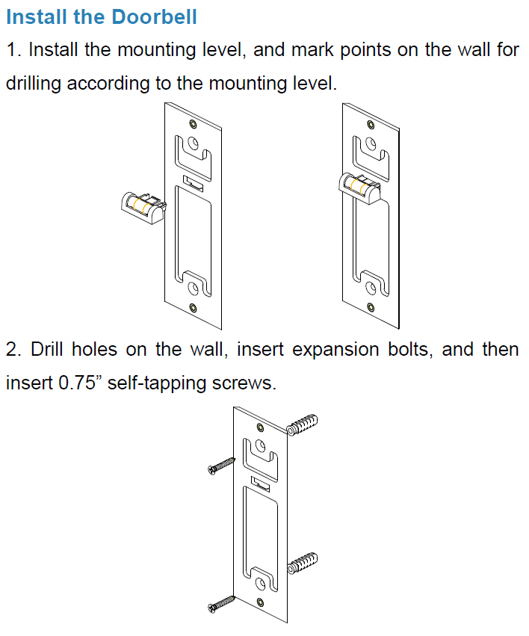

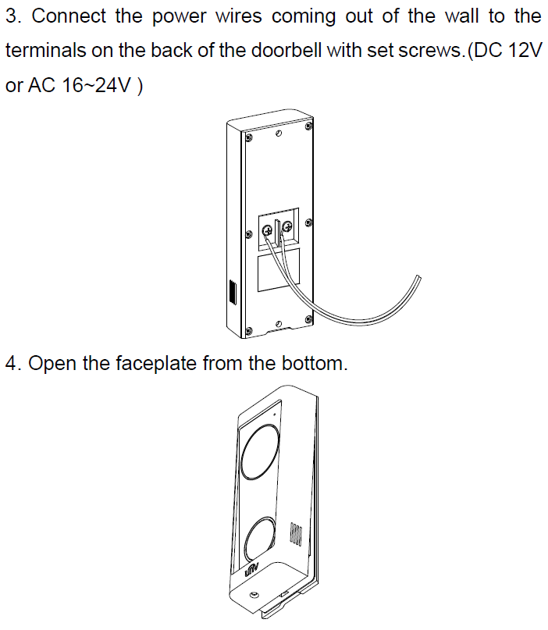

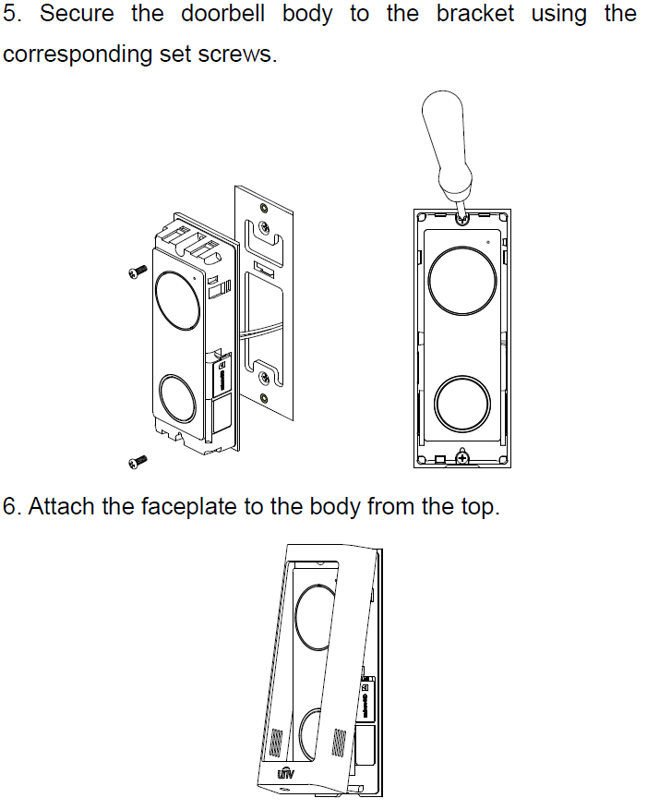

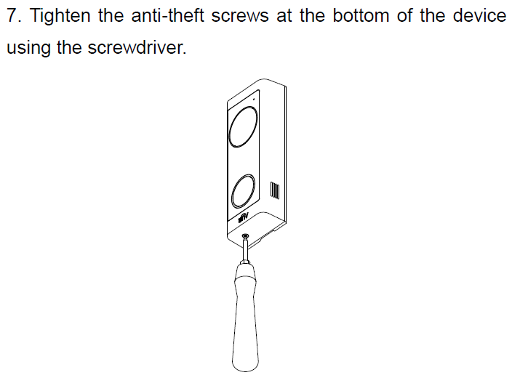

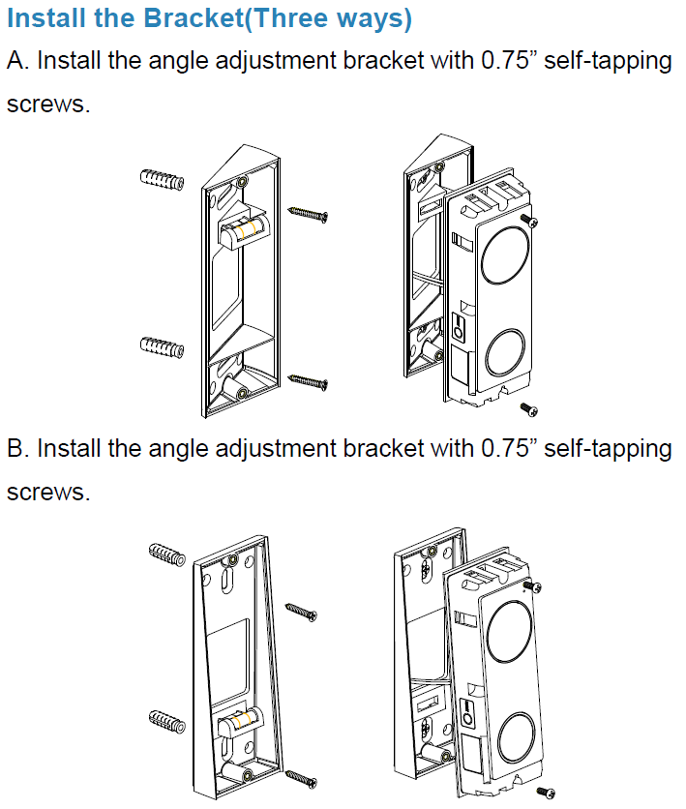

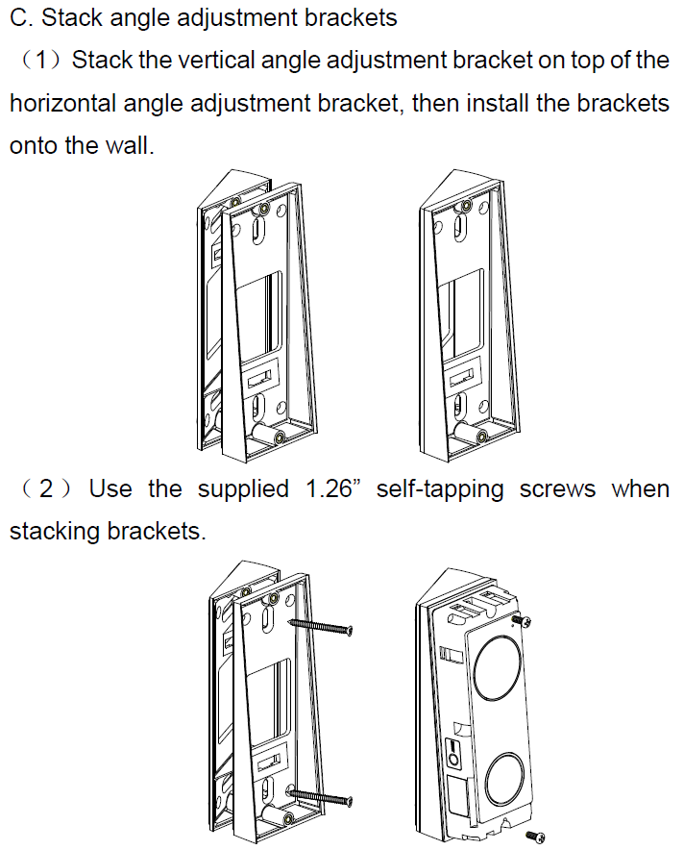

# EZLive mobile app

EZLive is a (new) mobile app of Uniview. This app is made for end users and has a more simple interface as EZView. Both apps are working with the same account. Only EZLive is working with the doorbell. Of course this app is available for Android and iOS.

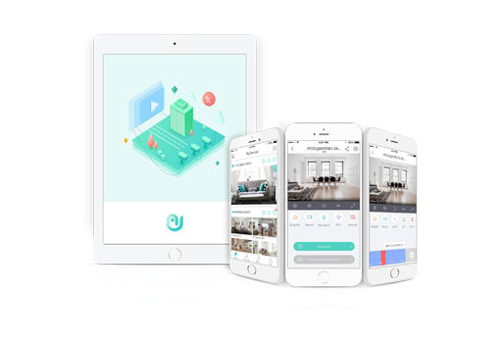

# Setup

**Make sure that your mobile phone is connected to the Wi-Fi network, the same network that the doorbell will be connected to. This has to be 2.4Ghz, NOT 5Ghz.**

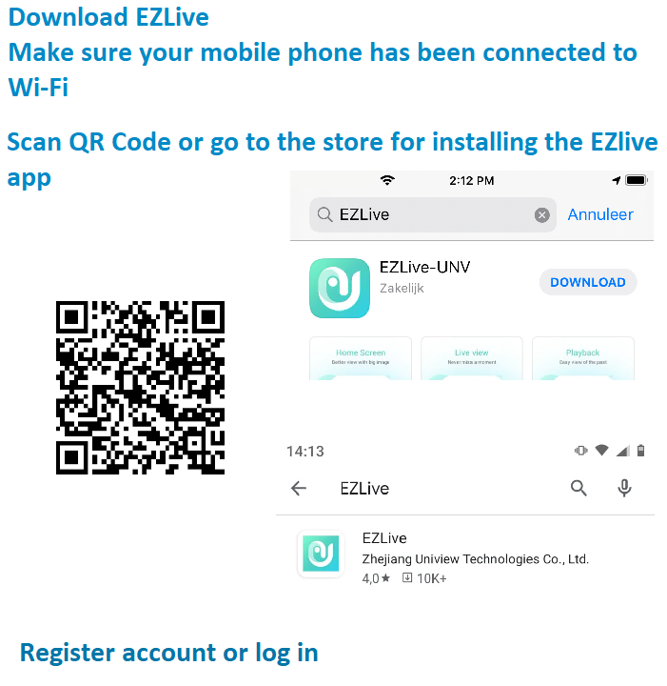

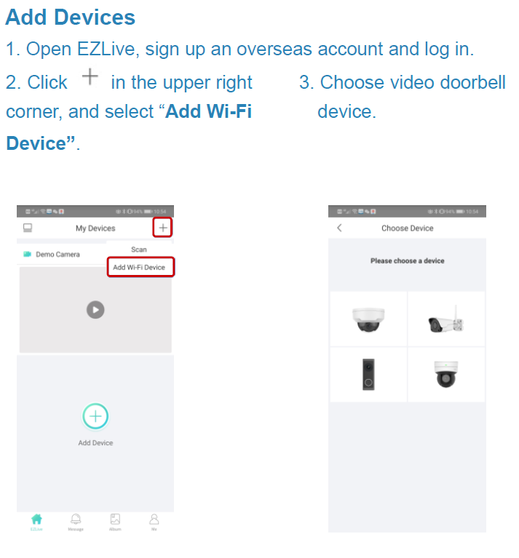

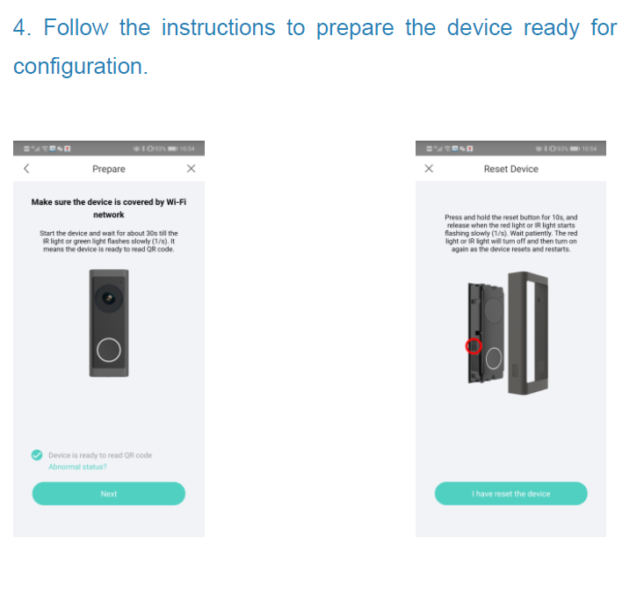

In case the Wi-Fi settings will not be taken automatically you have to type type them yourself.

The QR code of the device can be found on the left side of the device and on the manual that is delivered with it.

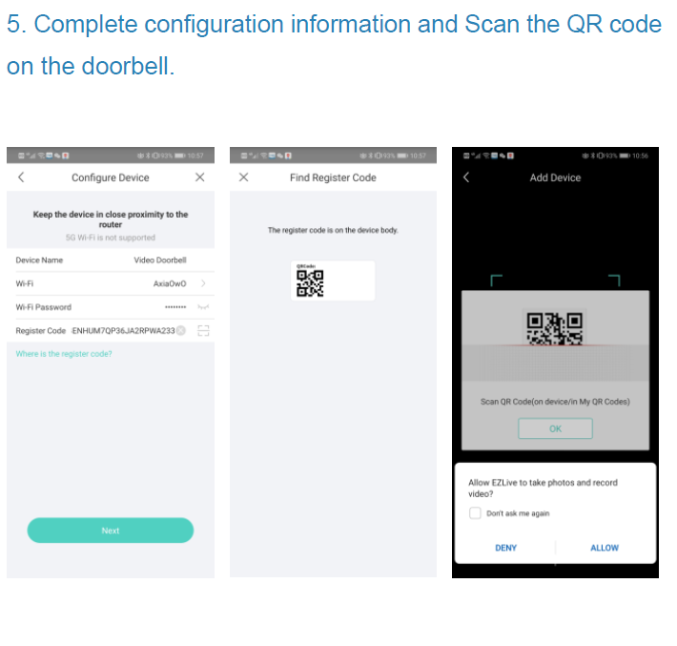

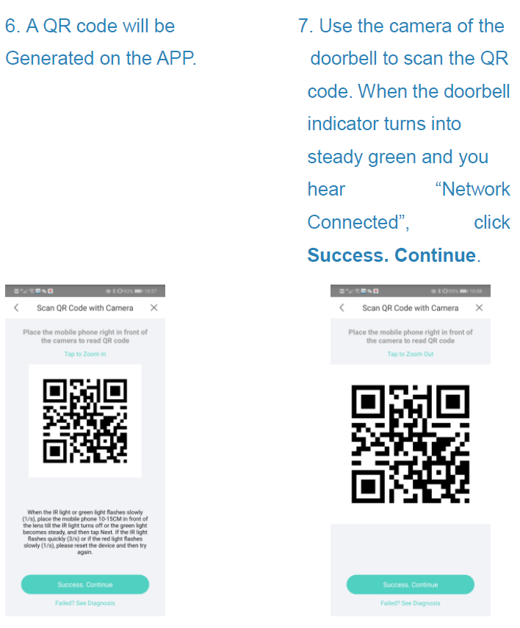

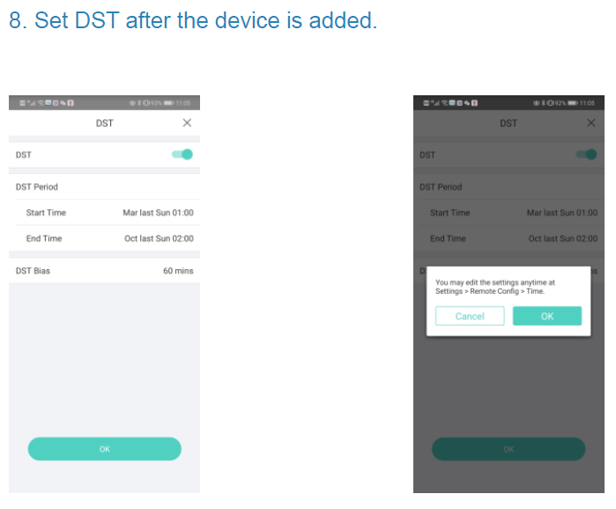

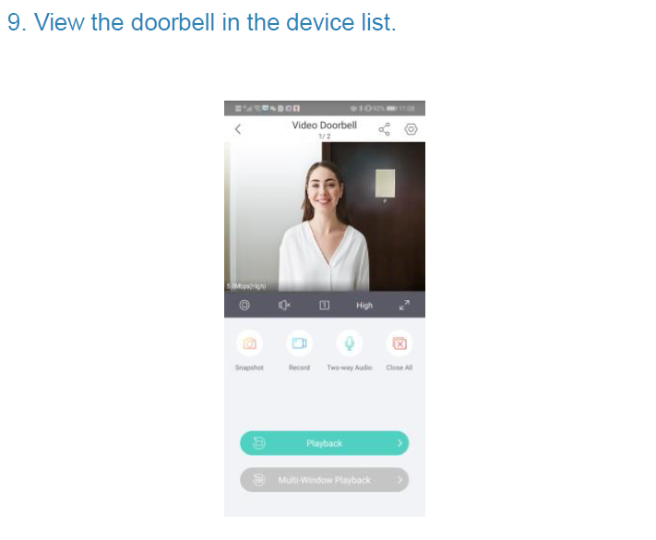

# Factory Default

Delete the device from the device list in EZLive app. After that remove the faceplate from the device and hold the reset button for about 15 seconds. LED indication will blink red for some time, the device will reboot.

After that, device is back to default settings. It will give voice commands for cloud connection.

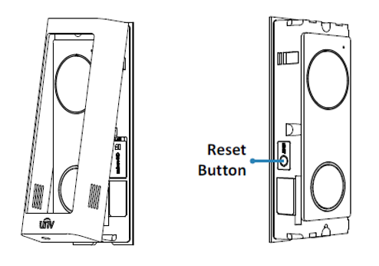

# Share with other user

(Dutch screenshots) It is possible to share device with other users. ‘Deel met’ means ‘Share with’

You have to type in the username or email address of the user (Screenshot 5)

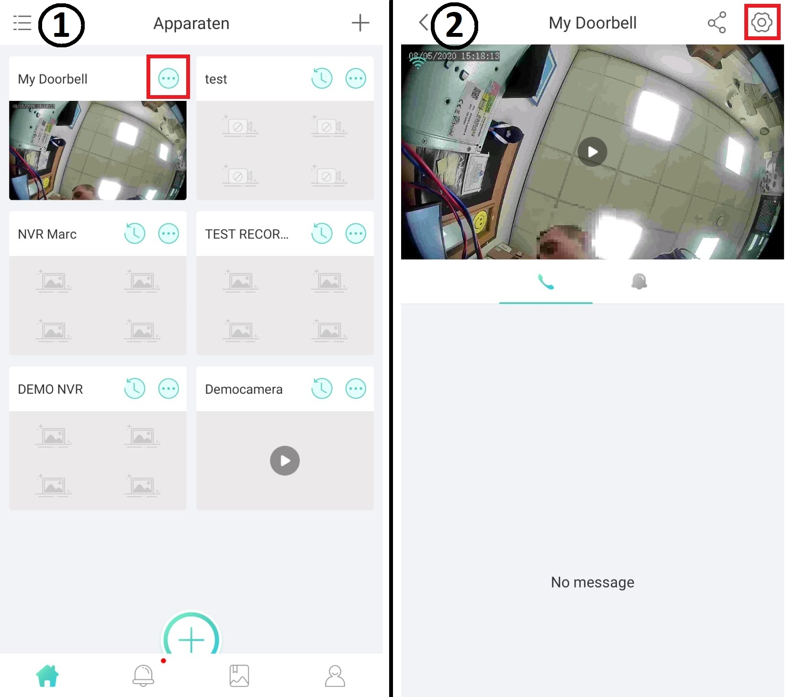

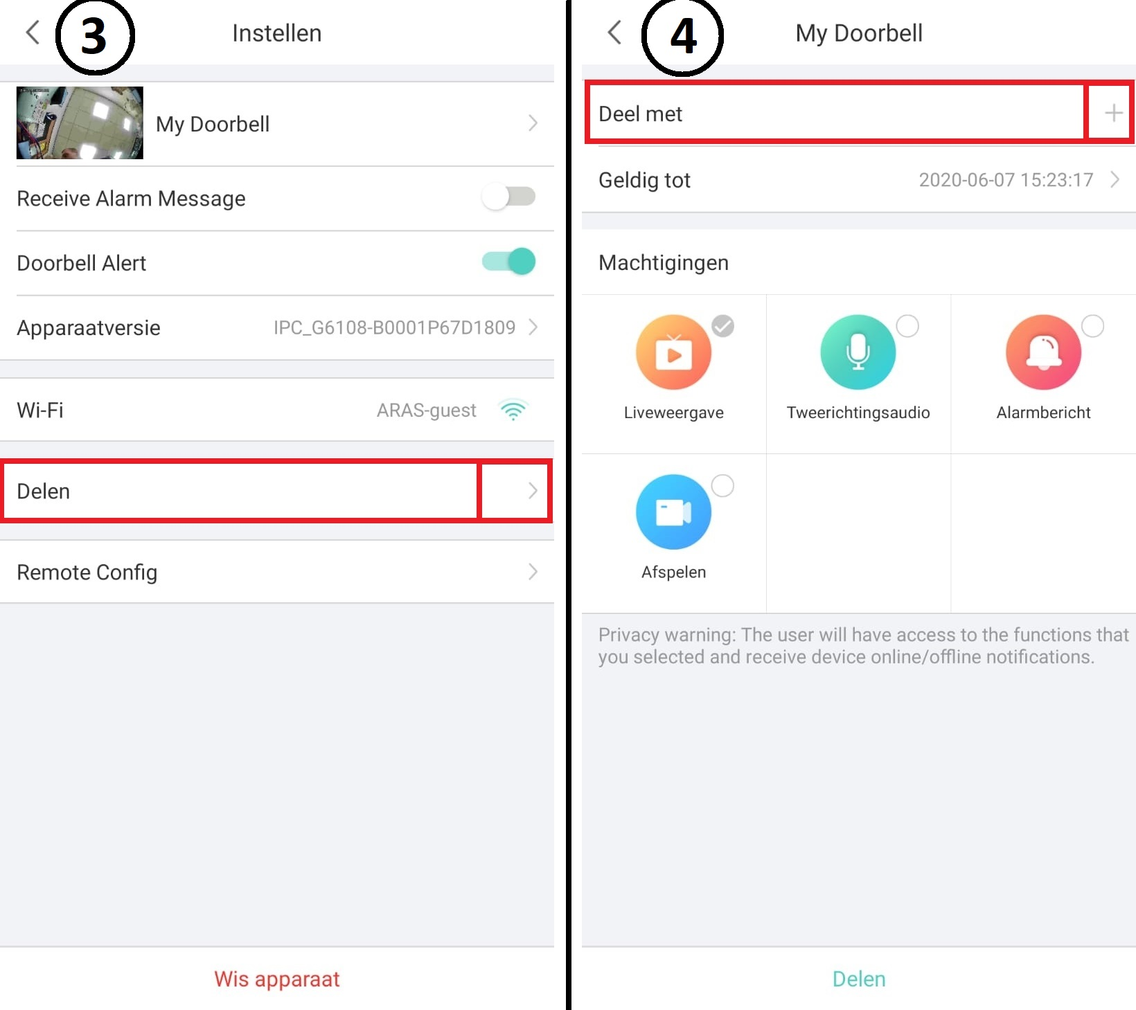

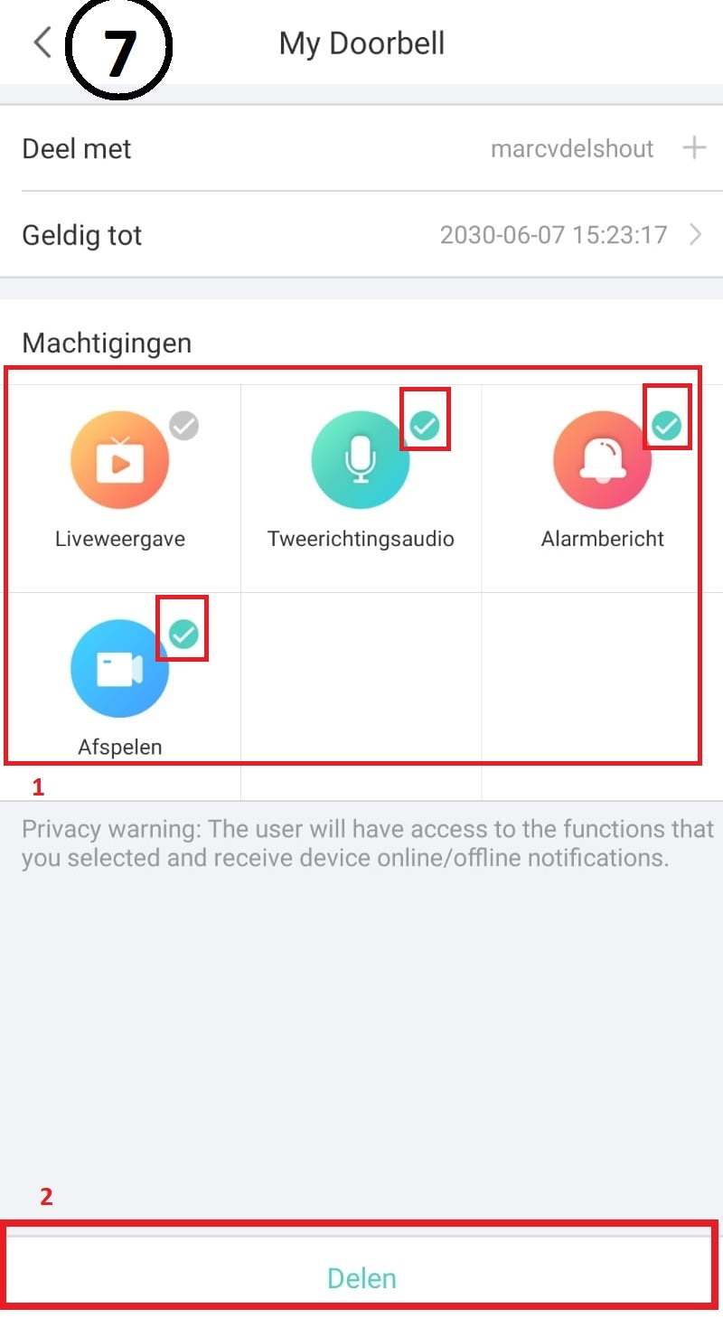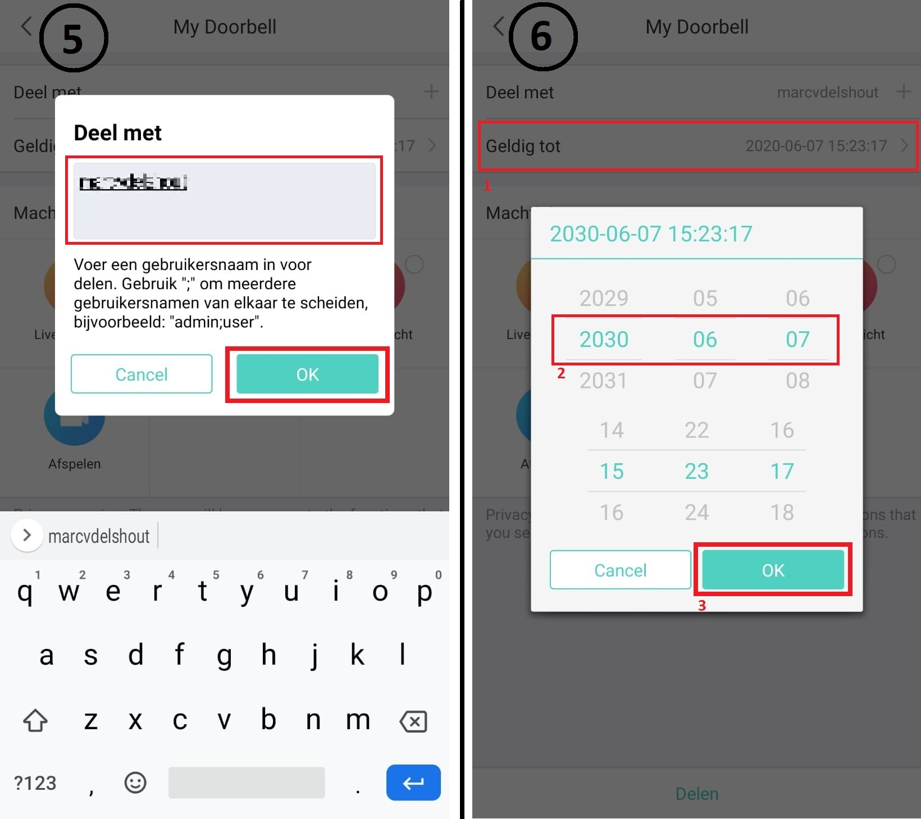

# Settings iPhone

To receive the push notification when someone press the doorbell there has to be some configuration.

After installing EZLive en opening the app for the first time it will ask permission for camera, location en sending messages. You have to allow this.

Also there will be a privacy policy message appear, agree with that.

Check after that if all message settings are correct:

iPhone settings > EZLive > Notifications: Make sure everything is turned on.

# Settings Android

Note: Every Android device is different and because of that it is possible that there is difference regarding functionality. It is also possible that there is an extra function on the mobile device that causes issues regarding push notifications.

After installing the EZLive app and opening it for the first time it will ask for permission for file access and there will be a privacy policy pop-up, accept it.

In case app messages/push notifications are not working fine check next settings:

(this can be different on every Android device)

Notification settings android > EZLive > Notifications > Show notifications > ON

Notification settings android > EZLive > Notifications > Show on screen > ON

Notification settings android > EZLive > Notifications > lock screen > ‘Show all content’

Notification settings android > EZLive > Notifications > Ignore do not disturb > ON

Notification settings android > EZLive > Advanced > show over other apps > ALLOW

# Important

- Doorbell does not work with 5Ghz Wi-Fi, only 2.4Ghz

- Make sure router/AP distance from doorbell is not too far way

- Recommended installation height is 1.6 m

- Do not install doorbell on metal because of signal interference.

- The mainstream is live while having a doorbell call.

In case this is not stable, because of Wi-Fi issues maybe some stream adjustment can make a difference.

To change settings of the stream the web interface of the doorbell has to be opened.

That is possible on two ways:

In LAN, scan with EZTools to know IP-Address of the device, enter that address in Internet Explorer 11. Install plug-in if needed/when asked.

Outside LAN, go to EZCloud login page (also with Internet Explorer 11)

Login in with default settings, admin & 123456

Stream settings: Setup > Video & Audio > Video > Mean Stream

**Please contact me for questions or if you want to report mistakes regarding this file.**

**Best regards,**

**Marc**

**Junior Support Engineer**

**Mail:** [**marc.vandenelshout@aras.nl**](mailto:marc.vandenelshout@aras.nl)

**Telegram: MARC4ARAS**