**NOTIFIED BODY EU-TYPE EXAMINATION CERTIFICATE NTEK1191** / **3 Feb 2021** / **Rev A** 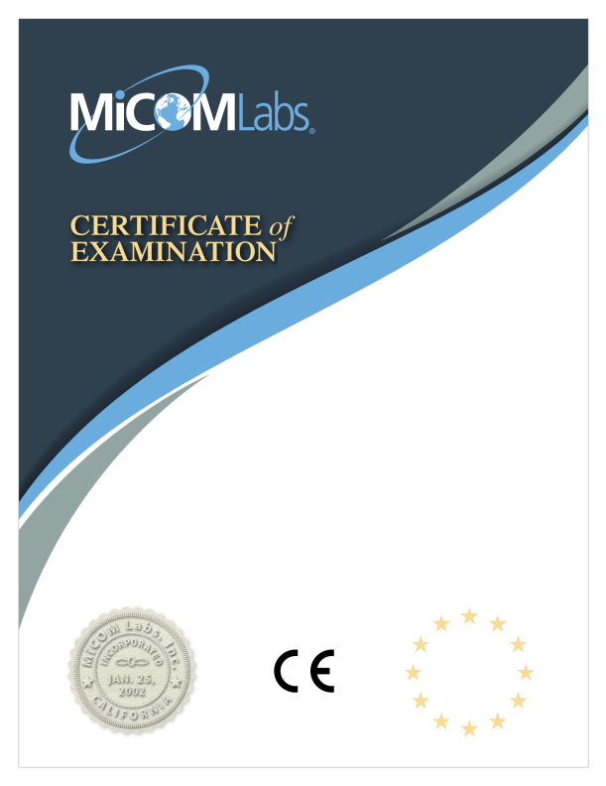

**Radio Equipment Directive (RED) 2014/53/EU**

MiCOM Labs Inc., Notified Body Number 2280 declares, on the basis of the assessment of the tests and the technical documentation provided by the applicant that the following product complies with the essential requirements of the above noted Directive.

Product Name:

**Motion detector with camera**

Approval Holder Name:

**AJAX SYSTEMS CYPRUS HOLDINGS LTD**

**Gordon Hurst, Product Certifier**

This Certificate is Issued under the Authority of:

1

.

**MiCOM Labs Inc., 575 Boulder Court, Pleasanton, California 94566, USA**

2

v

t

r

Notified Body Number: 2280

e

C

-

c

o

D

NTEK1191 Page 1 of 6 NTEK1191

**Notified Body EU-Type Examination Certificate** 

**NTEK1191** / **3 Feb 2021** / **Rev A**

**for Radio Equipment Directive (RED) 2014/53/EU**

Product Name:

**Motion detector with camera**

Product Model Numbers: **Ajax MotionCam**

Brand Name: **AJAX**

**Approval Holder: AJAX SYSTEMS CYPRUS HOLDINGS LTD**, Ifigeneias, 17, Strovolos, 2007, Nicosia, Cyprus **Product Manufacturer: "AJAX SYSTEMS MANUFACTURING" LIMITED LIABILITY COMPANY**, Sklyarenka, 5, Kyiv, 04073, Ukraine

**Standards**

**Group Name**

Article 3.1(a) Health & Safety EN 62479:2010

EN 62368-1:2014+A11:2017

Article 3.1(b) Electromagnetic Compatibility EN 301 489-1 V2.2.3

EN 301 489-3 V2.1.1

Article 3.2 Effective Use of Spectrum EN 300 220-1 V3.1.1

EN 300 220-2 V3.2.1

1

.

2

v

t

r

e

C

-

c

o

D

MiCOM Labs, 575 Boulder Court, Pleasanton, California 94566, USA

Tel: +1 (925) 462-0304, Fax: +1 (925) 462-0306, Web: www.micomlabs.com

NTEK1191 Page 2 of 6 NTEK1191

**Notified Body EU-Type Examination Certificate** 

**NTEK1191** / **3 Feb 2021** / **Rev A**

**for Radio Equipment Directive (RED) 2014/53/EU**

**Annex 1 to EU-Type Examination**

**EU-Type examination on the essential requirements**

**Article 3**

**Article 3.1** - a) Health and Safety Assessed

**Article 3.1** - b) Electromagnetic compatibility Assessed

**Article 3.2** - Effective use of radio spectrum Assessed

**Article 3.3** - a) interworks with Accessories/Chargers Not Assessed

**Article 3.3** - b) interworks with Radio Networks Not Assessed

**Article 3.3** - c) can connect to interfaces Not Assessed

**Article 3.3** - d) does not harm the network, misuse network resources Not Assessed

**Article 3.3** - e) privacy protections Not Assessed

**Article 3.3** - f) fraud protections Not Assessed

**Article 3.3** - g) emergency services access Not Assessed

**Article 3.3** - h) assist users with disabilities Not Assessed

**Article 3.3** - i) integrity of software Not Assessed

**Description of Apparatus**

Company Name**AJAX SYSTEMS CYPRUS HOLDINGS LTD**

Certification No.**NTEK1191**

Issue Date / Rev**3 Feb 2021 / Rev A**

Equipment Description**Motion detector with camera**

Hardware Version**CAM.001.MBR.000v5 CAM.001.PIR.000v5**

Firmware Version**MotionCam 5.52.1.0**

**Emission Information**

| **Frequency**  **RF Power**  **Technology**  **Emission Designator**  **From To**  **Max. Type Field Strength** |
| --- |
| SRD 868.1MHz 868.1MHz 2.204mW ERP -- |
| SRD 868.3MHz 868.3MHz 2.080mW ERP -- |
| SRD 868.5MHz 868.5MHz 1.779mW ERP -- |

1

.

2

v

t

r

e

C

-

c

o

D

MiCOM Labs, 575 Boulder Court, Pleasanton, California 94566, USA

Tel: +1 (925) 462-0304, Fax: +1 (925) 462-0306, Web: www.micomlabs.com

NTEK1191 Page 3 of 6 NTEK1191

**Technical Report(s):**

**Notified Body EU-Type Examination Certificate**

**NTEK1191** / **3 Feb 2021** / **Rev A**

**for Radio Equipment Directive (RED) 2014/53/EU**

**Technical Construction File Details: (Documents Reviewed)**

**Supporting Documentation:**

Article 3.1(a) Health & Safety:

S21011103320001

13840-21

Article 3.1(b) Electromagnetic Compatibility: S21011103320003

Article 3.2 Effective Use of Spectrum: S21011103320002

Service Agreement

Agent Authorization

EU Application

EU Declaration of Conformity

External Photographs

Label and its Location

User Manual

NTEK825_EU_Cert

Ajax MotionCam_RiskAssessment

Ajax MotionCam_Construction Equality Declaration **Scope**

This EU-Type Examination Certificate is given in respect of compliance of radio spectrum use Article 3 Paragraph 2 of the RED Directive 2014/53/EU. The scope of the evaluation and this certificate relates only to those items identified in 'Annex 1 to EU - Type Examination Certificate' for the specific product and Certificate number referenced above. 

EU Type Examination was performed according to Module B: EU-type examination procedure per Annex III the Directive on the essential requirements in Article 3, for the specific product and Certificate Number referenced above.

This EU Type Examination Certificate is based upon the review of the Technical Documentation and supporting evidence for the adequacy of the technical design solution, it is only valid in conjunction with the attached Annexes. The scope of this statement relates to a single sample of the apparatus identified above and of the submitted documents only.

1

.

2

v

t

r

e

C

-

c

o

D

MiCOM Labs, 575 Boulder Court, Pleasanton, California 94566, USA

Tel: +1 (925) 462-0304, Fax: +1 (925) 462-0306, Web: www.micomlabs.com

NTEK1191 Page 4 of 6 NTEK1191

**Notified Body EU-Type Examination Certificate** 

**NTEK1191** / **3 Feb 2021** / **Rev A**

**for Radio Equipment Directive (RED) 2014/53/EU**

**Annex 2 to EU-Type Examination**

**Obligations of the Applicant**

**Ref RED 2014/53/EU Article 10 - Obligations of manufacturers**

1. When placing their radio equipment on the market, manufacturers shall ensure that it has been designed and manufactured in accordance with the essential requirements set out in Article 3.

2. Manufacturers shall ensure that radio equipment shall be so constructed that it can be operated in at least one Member State without infringing applicable requirements on the use of radio spectrum.

3. Manufacturers shall draw up the technical documentation referred to in Article 21 and carry out the relevant conformity assessment procedure referred to in Article 17 or have it carried out. Where compliance of radio equipment with the applicable requirements has been demonstrated by that conformity assessment procedure, manufacturers shall draw up an EU declaration of conformity and affix the CE marking.

4. Manufacturers shall keep the technical documentation and the EU declaration of conformity for 10 years after the radio equipment has been placed on the market.

5. Manufacturers shall ensure that procedures are in place for series production to remain in conformity with this Directive. Changes in radio equipment design or characteristics and changes in the harmonised standards or in other technical specifications by reference to which conformity of radio equipment is declared shall be adequately taken into account.

When deemed appropriate with regard to the risks presented by radio equipment, manufacturers shall, to protect the health and safety of end-users, carry out sample testing of radio equipment made available on the market, investigate, and, if necessary, keep a register of complaints, of non-conforming radio equipment and radio equipment recalls, and shall keep distributors informed of any such monitoring.

6. Manufacturers shall ensure that radio equipment which they have placed on the market bears a type, batch or serial number or other element allowing its identification, or, where the size or nature of the radio equipment does not allow it, that the required information is provided on the packaging, or in a document accompanying the radio equipment.

7. Manufacturers shall indicate on the radio equipment their name, registered trade name or registered trade mark and the postal address at which they can be contacted or, where the size or nature of radio equipment does not allow it, on its packaging, or in a document accompanying the radio equipment. The address shall indicate a single point at which the manufacturer can be contacted. The contact details shall be in a language easily understood by end-users and market surveillance authorities.

8. Manufacturers shall ensure that the radio equipment is accompanied by instructions and safety information in a language which can be easily understood by consumers and other end-users, as determined by the Member State concerned. Instructions shall include the information required to use radio equipment in accordance with its intended use. Such information shall include, where applicable, a description of accessories and components, including software, which allow the radio equipment to operate as intended. Such instructions and safety information, as well as any labelling, shall be clear, understandable and intelligible.

The following information shall also be included in the case of radio equipment intentionally emitting radio waves:

(a) frequency band(s) in which the radio equipment operates;

(b) maximum radio-frequency power transmitted in the frequency band(s) in which the radio equipment operates.

9. Manufacturers shall ensure that each item of radio equipment is accompanied by a copy of the EU declaration of conformity or by a simplified EU declaration of conformity. Where a simplified EU declaration of conformity is provided, it shall contain the exact internet address where the full text of the EU declaration of conformity can be obtained.

10. In cases of restrictions on putting into service or of requirements for authorisation of use, information available on the packaging shall allow the identification of the Member States or the geographical area within a Member State where restrictions on putting into service or requirements for authorisation of use exist. Such information shall be completed in the instructions accompanying the radio equipment. The Commission may adopt implementing acts specifying how to present that information. Those implementing acts shall be adopted in accordance with the advisory procedure referred to in Article 45(2).

1

.

2

v

t

r

e

C

-

c

o

D

MiCOM Labs, 575 Boulder Court, Pleasanton, California 94566, USA

Tel: +1 (925) 462-0304, Fax: +1 (925) 462-0306, Web: www.micomlabs.com

NTEK1191 Page 5 of 6 NTEK1191

**Notified Body EU-Type Examination Certificate** 

**NTEK1191** / **3 Feb 2021** / **Rev A**

**for Radio Equipment Directive (RED) 2014/53/EU**

11. Manufacturers who consider or have reason to believe that radio equipment which they have placed on the market is not in conformity with this Directive shall immediately take the corrective measures necessary to bring that radio equipment into conformity, to withdraw it or recall it, if appropriate. Furthermore, where the radio equipment presents a risk, manufacturers shall immediately inform the competent national authorities of the Member States in which they made the radio equipment available on the market to that effect, giving details, in particular, of the noncompliance, of any corrective measures taken and of the results thereof.

12. Manufacturers shall, further to a reasoned request from a competent national authority, provide it with all the information and documentation in paper or electronic form necessary to demonstrate the conformity of the radio equipment with this Directive, in a language which can be easily understood by that authority. They shall cooperate with that authority, at its request, on any action taken to eliminate the risks posed by radio equipment which they have placed on the market.

**Ref RED 2014/53/EU Article 11 - Authorised representatives**

1. A manufacturer may, by a written mandate, appoint an authorised representative.

The obligations laid down in Article 10(1) and the obligation to draw up technical documentation laid down in Article 10(3) shall not form part of the authorised representative's mandate.

2. An authorised representative shall perform the tasks specified in the mandate received from the manufacturer. The mandate shall allow the authorised representative to do at least the following:

(a) keep the EU declaration of conformity and the technical documentation at the disposal of national market surveillance authorities for 10 years after the radio equipment has been placed on the market;

(b) further to a reasoned request from a competent national authority, provide that authority with all the information and documentation necessary to demonstrate the conformity of radio equipment;

(c) co-operate with the competent national authorities, at their request, on any action taken to eliminate the risks posed **Article 19 General principles of the CE marking**

1.The CE marking shall be subject to the general principles set out in Article 30 of Regulation (EC) No 765/2008.

2.On account of the nature of radio equipment, the height of the CE marking affixed to radio equipment may be lower than 5 mm, provided that it remains visible and legible.

**Article 20 Rules and conditions for affixing the CE marking and the identification number of the notified body**

1.The CE marking shall be affixed visibly, legibly and indelibly to the radio equipment or to its data plate, unless that is not possible or not warranted on account of the nature of radio equipment. The CE marking shall also be affixed visibly and legibly to the packaging.

2.The CE marking shall be affixed before the radio equipment is placed on the market.

3.Member States shall build upon existing mechanisms to ensure correct application of the regime governing the CE marking and shall take appropriate action in the event of improper use of that marking.

1

.

2

v

t

r

e

C

-

c

o

D

MiCOM Labs, 575 Boulder Court, Pleasanton, California 94566, USA

Tel: +1 (925) 462-0304, Fax: +1 (925) 462-0306, Web: www.micomlabs.com

NTEK1191 Page 6 of 6 NTEK1191